Visual Composition Shot List Template

GENERAL INFO

- Your Name:_Lindsey Komson_____________________________
- PROJECT: Montage of a place
- What camera are you using? (be specific)_Canon EOS Rebel T6________________________

DIRECTIONS:
- These are modified versions of the exercises found in The Bare Bones Camera Course by Tom Schroeppel (page 145). Review chapters 2, 3, and 5 as needed.
- For this pre-production portion, you should take STILL PHOTOS (NOT video) in the location that your montage will be focused on. I would suggest printing this document out as a check list.
- Take your photos in landscape (horizontal) orientation (NOT vertical/portrait).
- Once you have taken the photos, insert JPG files into this document.
  - *NOTE: If you have a high quality camera (DSLR for example), it might take really large photos that will make this document too large in file size to work with. Use a program like Photoshop to resize your photos to something more manageable. Maybe 800 pixels wide. See tutorial on Blackboard for details on how to do this.
- Save this document as you go in case it closes unexpectedly.
- Create a PDF file when complete for posting.

SHOT LIST

- COMPOSITION – RULE OF THIRDS
The Rule of Thirds gives us a visual framework within which we can place elements in our shot for maximum effect.
  - First, take a photo with one principal subject in the exact center of the frame. Insert that photo here:

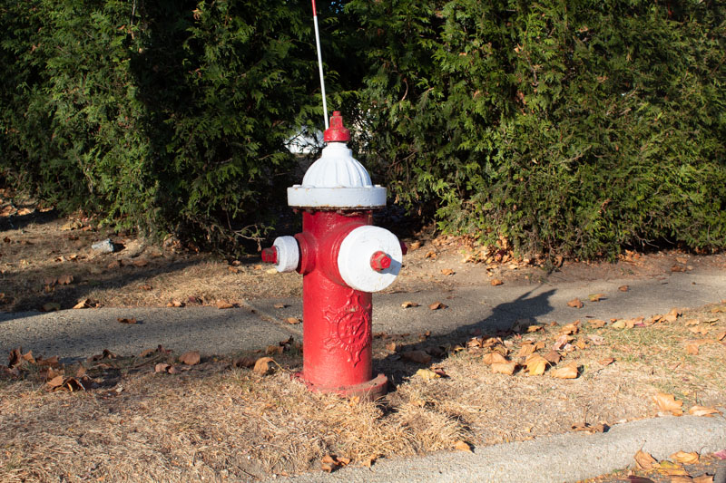

  - Then, reframe the same scene by moving your camera or changing positions to clearly demonstrates the Rule of Thirds by placing the subject in one of the 4 key positions. Insert that photo here:

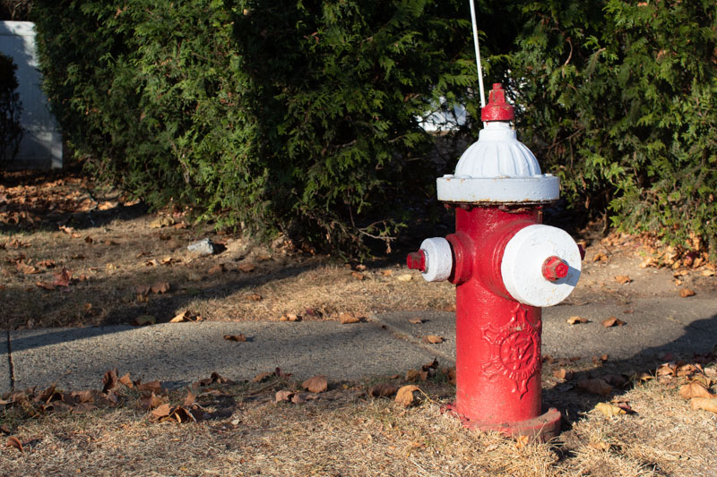

  - Now find another subject that is either closer to the camera or further away than the first subject. Take a photo with this subject in the exact center of the frame and insert it here:

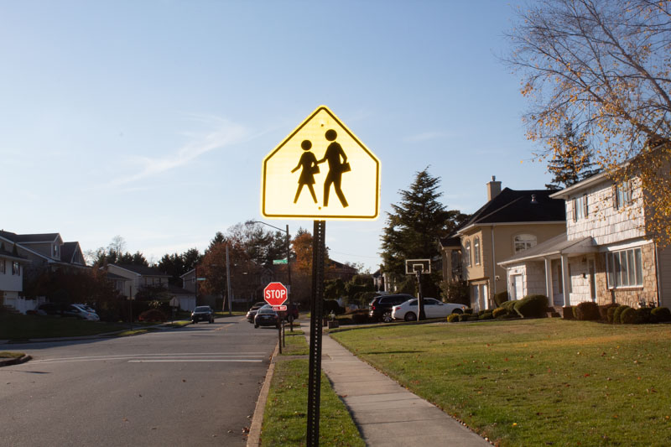

  - Finally, reframe this second subject using one of the other 4 placement points of the Rule of Thirds, and insert that photo here:

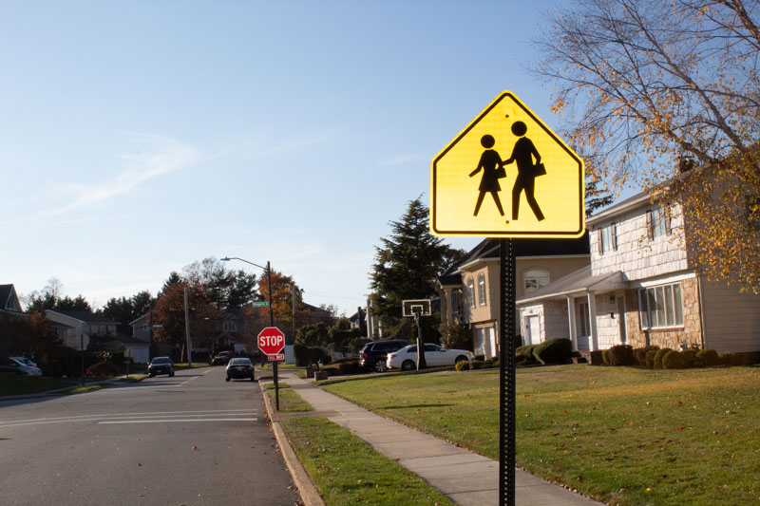

- BALANCE
Every element in the image has visual “weight” to it, and it’s essential to balance that weight.
  - First, pick an off-balance subject that doesn’t move and snap a photo with the subject centered in the frame. This can be a person looking out of the frame (needing “nose room” that it doesn’t have) or an object that requires balance (for example a chair that is facing to the side and it doesn’t have the nose room that it needs). Insert that un-balanced photo here:

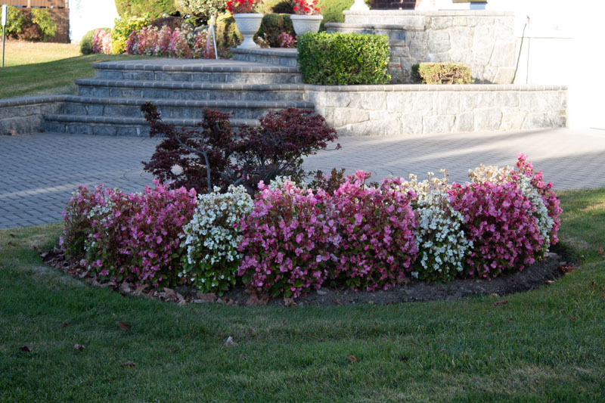

  - Then, reframe that subject with proper balance and proper noseroom. Insert that balanced photo here:

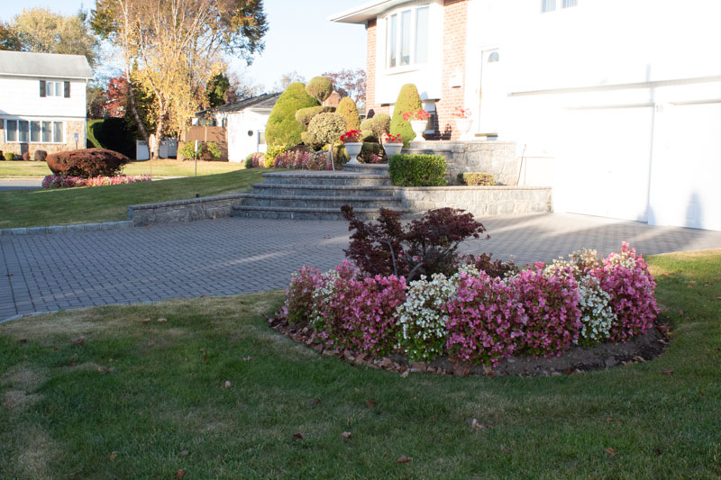

  - Second, select a moving subject, such as a car, that will require you to pan the camera to follow. While panning, snap a still photo of the subject exactly in the center of the frame (it will be unbalanced). Insert that unbalanced photo here:

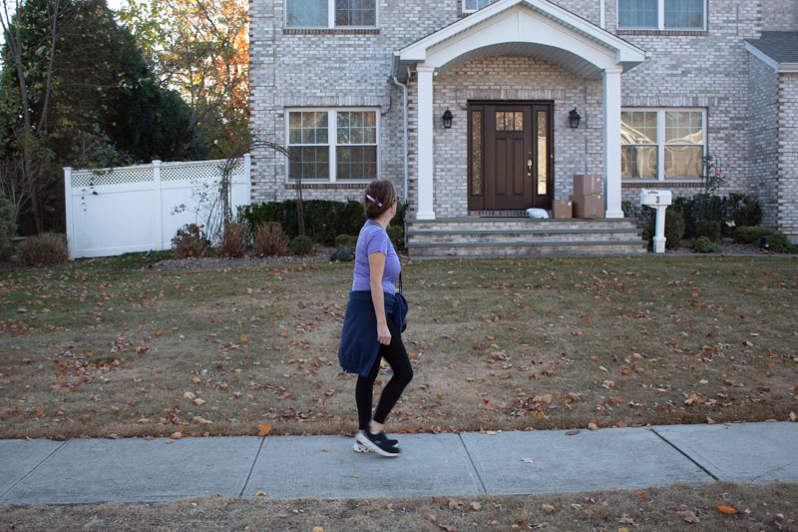

  - Now take another photo of the subject (or a similar subject) with proper framing and balance (i.e. proper noseroom in front of the car). Insert that balanced photo here:

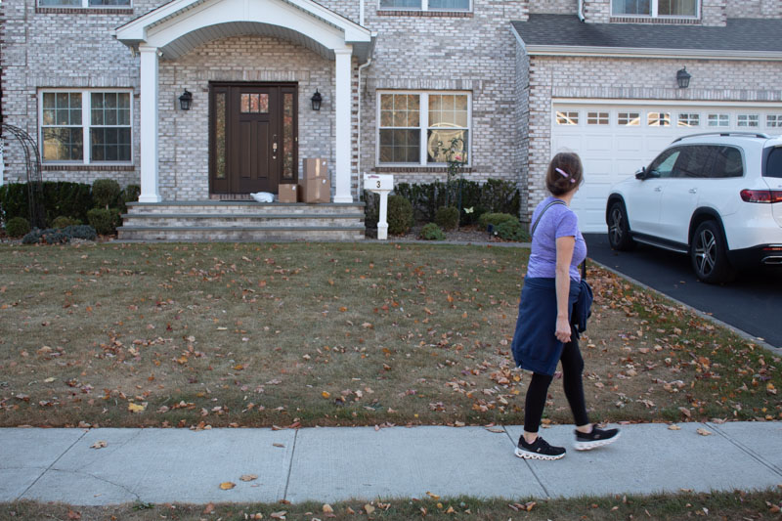

- ANGLES (DEPTH)
Photos and video images are typically flat and have only 2 dimensions. The third dimension, depth, can only be implied. One of the most important ways to accomplish this is to select an angle that gives the illusion of depth to your subject.
  - First, take a photo of an object using a camera position that does not give a sense of depth (flat and 2 dimensional). Insert that photo here:

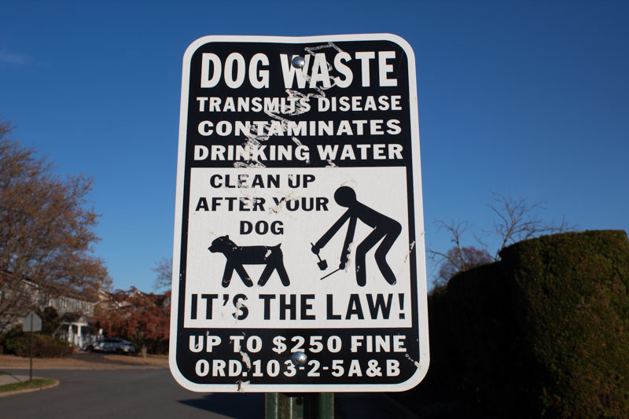

  - Then, change your camera position to add a sense of depth (3D with foreground, mid-ground, and background). Insert that photo here:



- NATURAL FRAMES IN THE SCENE
Framing is a very useful way to guide the viewer’s eye into the scene and to give emphasis to your subject. It is basically a visual border around the edges of your frame.
  - First, identify a usable frame that you can use for your subject. This can be something to look through like a window, fence, doorway, etc. or something natural like tree branches or rock formation. Take a photo of your subject without the framing element. Insert that photo here:

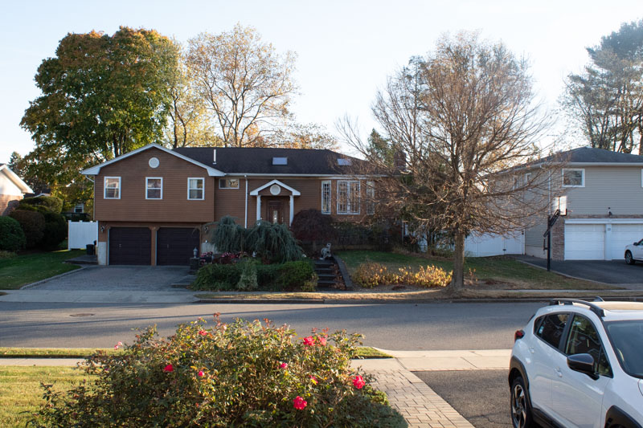

  - Then, change your camera position to include the framing element. Insert that photo here:

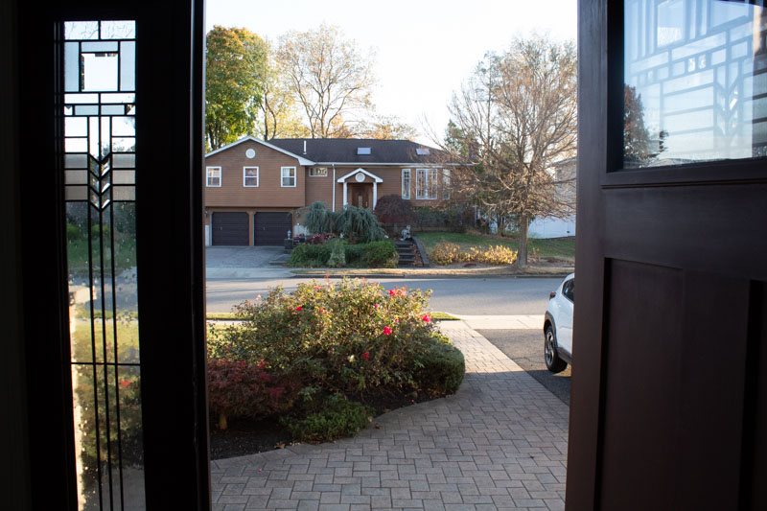

- LEADING LINES
Lines are like visual arrows for our eyes. These can be fences, roads, buildings, arrows, paths, seams, tracks, stairs, etc. that the viewer’s eyes will follow.
  - Take a WS or MS (wide or medium shot) photo of one subject with leading lines steering the audience’s eyes towards the subject. Insert that photo here:

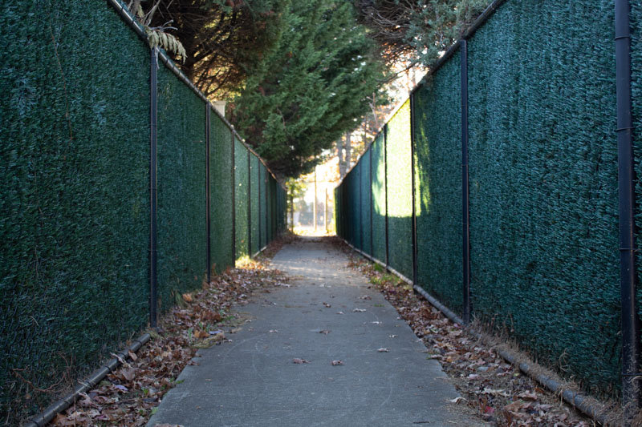

  - Do the same with another leading line and subject. Insert that photo here:

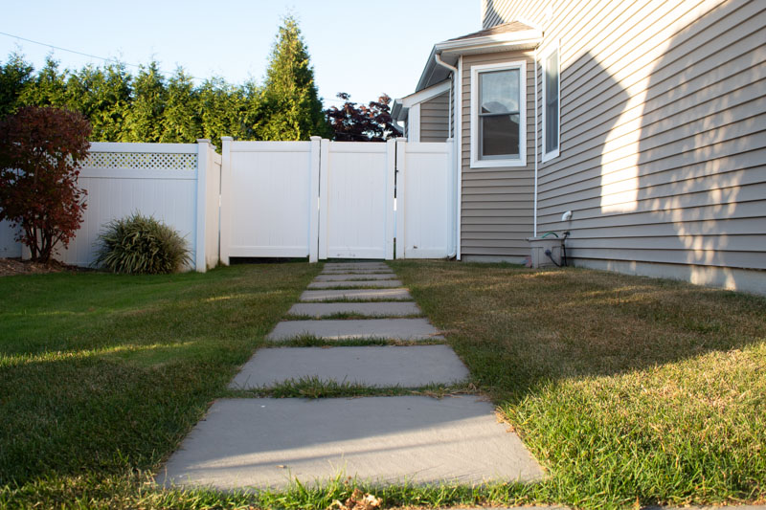

  - Do the same with a third leading line and subject. Insert that photo here:

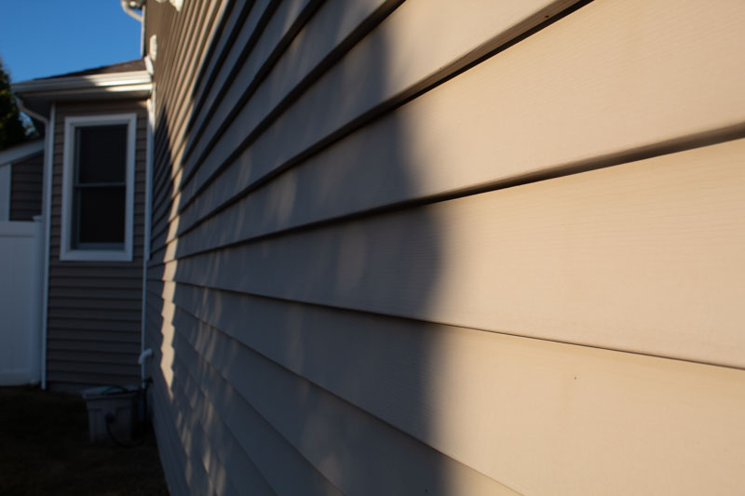

- BACKGROUNDS
Backgrounds can either distract from or enhance your subject. The first skill to master is learning to select backgrounds that don’t distract your viewer from the principal subject in the frame.
  - First, take a photo of a subject in front of a bland background (MS or WS). Use the rule of thirds and balance. Insert that photo here:



  - Then, take a photo of a subject in front of a busy (distracting) background. Insert that photo here:

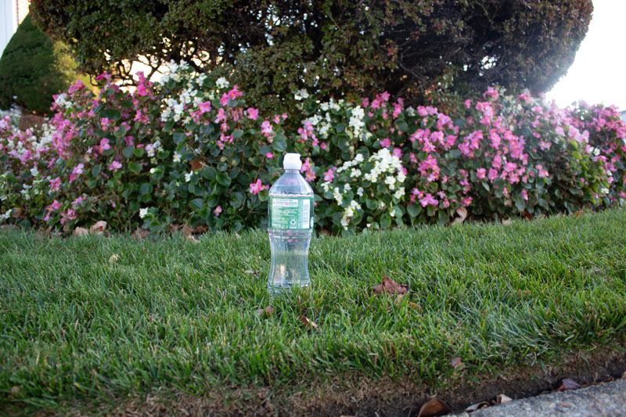

  - Now, try to “fix” your second shot by adjusting the background. Use shallow depth of field if possible (see #10 below), hide distracting elements with props, or change your distance and/or angle. Insert that photo here:

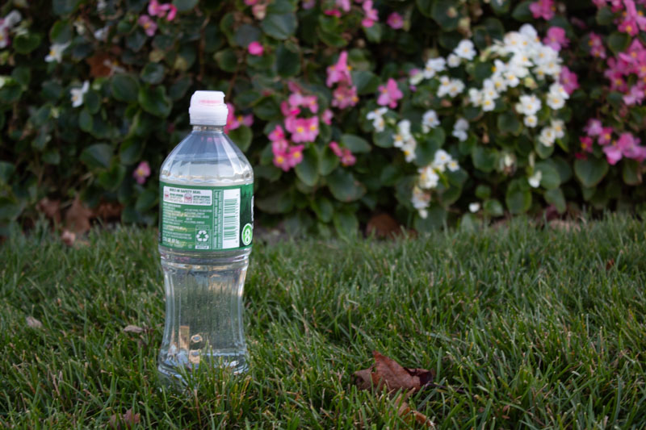

- BASIC SHOTS (SHOT FRAMING)
Select a location with a single subject that interests you, and practice framing options.
  - First, take a WS (Wide Shot) as an “establishing shot” of the subject. Insert that photo here:



  - Then, change your camera position and/or focal length to frame up a MS (Medium Shot) of the same subject. Insert that photo here:



  - Then, change your camera position and/or focal length to frame up a CS (Closeup Shot) of the same subject. Insert that photo here:



  - Then, change your camera position and/or focal length to frame up an ECU (Extreme Closeup Shot / Macro Shot) of the same subject. Insert that photo here:



- PERSPECTIVE
Try to give the audience a unique view. Get down low and look up. Get your camera high and look down. Look across something rather than straight on.
  - First, take a photo of a subject from an “ordinary” everyday perspective. Insert that photo here:

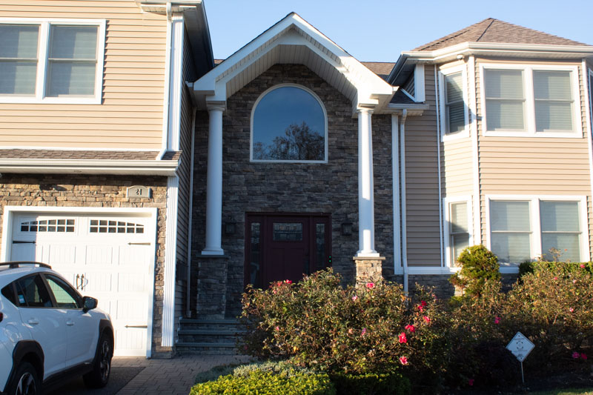

  - Then, change your camera position to capture a unique perspective of the same subject. Insert that photo here:

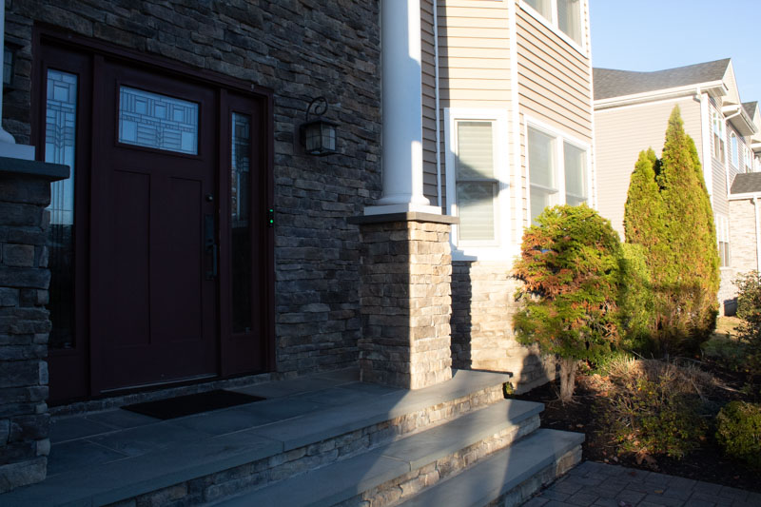

  - Capture another different perspective of the same subject. Insert that photo here:

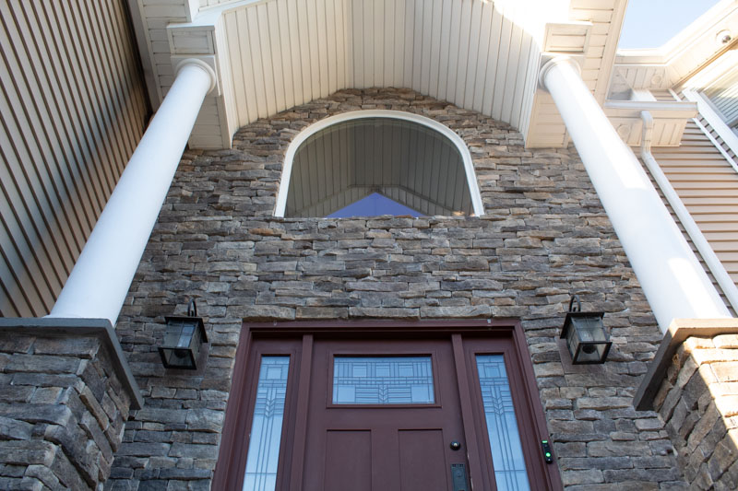

- SHALLOW DOF
“Depth of field” refers to how much in the shot is in focus. You might think that having everything in focus would be ideal, but actually it’s often better to have only part of the image in focus – that way the audience pays attention to that one part even more. With “shallow depth of field”, only part of the scene is in focus. In order to do this, you need to setup a scene that has true depth to it. For example, there needs to be a lot of space between your subject and the background. Then you can zoom way in and/or open up the iris on your camera to make one portion blurry.
  - First, take a photo of a subject with everything crisp and in focus. Insert that photo here:

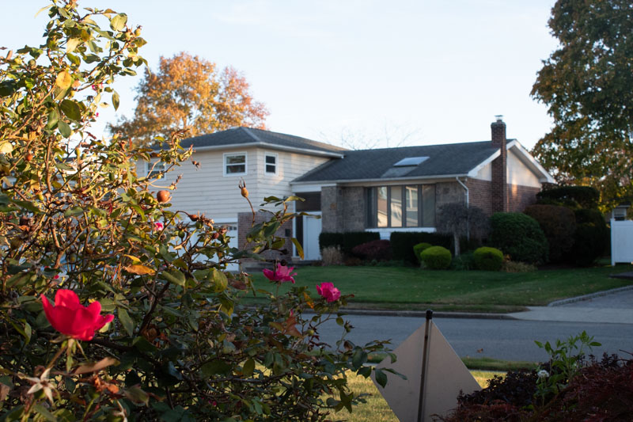

  - Then, change your camera focal length (zoom all the way in or swap to a long lens) and/or open up the iris to get “shallow depth of field”. Focus on your subject and let the background be blurry. Insert that photo here:

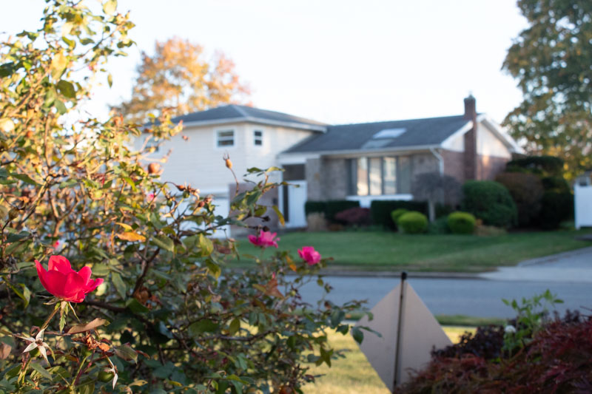

CREATE A PDF
When you are done creating this document, you should create a universal PDF document that can be easily posted to your blog or emailed (it’s not safe to assume everyone has Microsoft Word, and the files can be very large).

To do this on a Mac, click File>Print and then click the option for PDF in the lower left, followed by “Save to PDF”. Contact me if you need help on a PC.

